

**NORTHEASTERN UNIVERSITY**

**DATABASE MANAGEMENT SYSTEM**

**FINAL PROJECT-INFO 6210**

**SPOORHTI BELLAM**

**(001899142)**

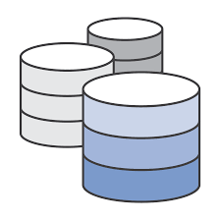**PROBLEM STATEMENT**

University database management system is required to manage the records of the students.As there is a huge amount of data for each category, Managing student information, generating of enrollment number are some of the modules of the University Management Systems database.

Sorting and accessing the data in the form of excel sheet is a tremendous work. it requires a lot of laborious work.,they should have to maintain the record of each and every student from starting it is so difficult and so costlier task.

So we used a database to solve the problem.

**So** here, we used sepearte tables for each category and used few joins to combine the data from two different categories and see it in one table easily making life simpler. We used triggers and views in our project to make few validation and to see few most frequently used tables

Some of the Key Tables:-

1.Branches

2.Address

3.Student

4.Professors

5.Courses

6.Classes

ER DIAGRAM:

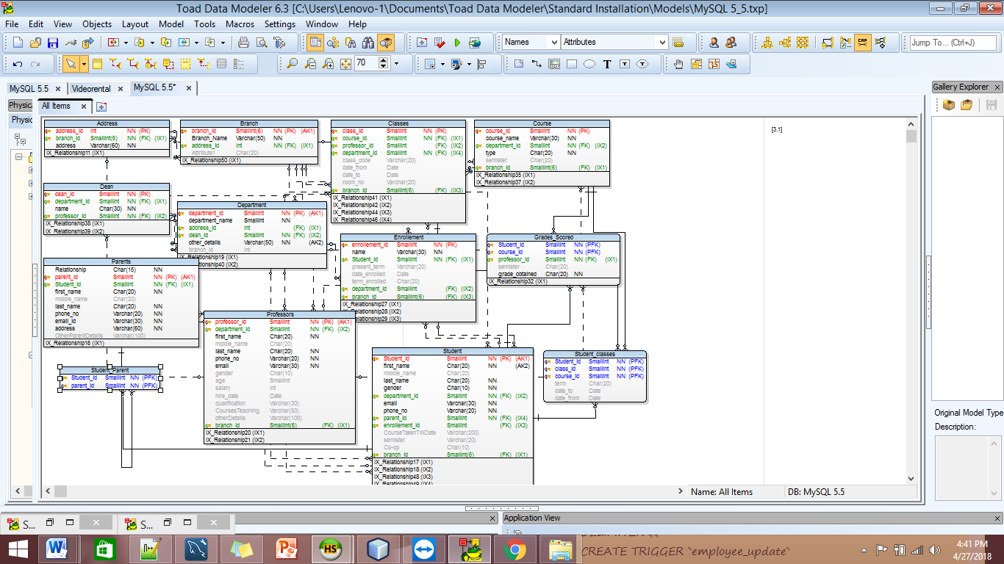

**VALIDATION TRIGGER:**

1)

DELIMITER $$

CREATE TRIGGER `professor_validate_insert`

BEFORE INSERT

ON `professors1`

FOR EACH ROW

BEGIN

IF NEW.`email` NOT LIKE '%_@%_.__%'

THEN

SIGNAL SQLSTATE VALUE '45000'

SET MESSAGE_TEXT = 'email column is not valid';

END IF;

END;

$$

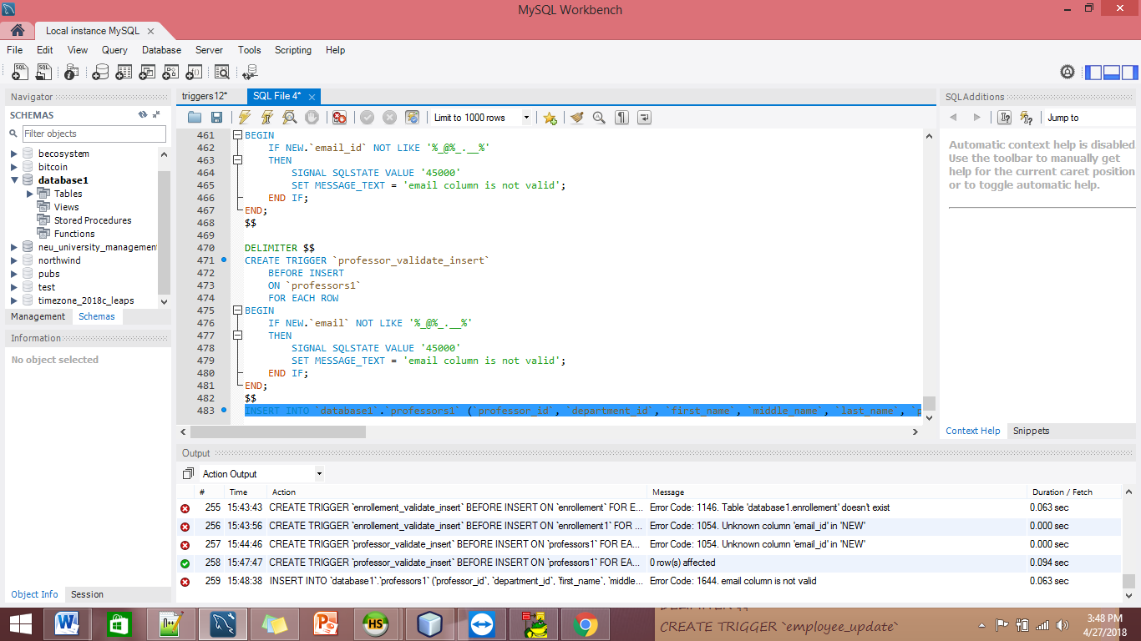

**TRIGGER FOR BACKUP FILE :**

CREATE TABLE IF NOT EXISTS `database1`.`professors_backup` (

`professor_id` SMALLINT(6) NOT NULL,

`department_id` INT NOT NULL,

`first_name` CHAR(20) NOT NULL,

`middle_name` CHAR(20) NULL DEFAULT NULL,

`last_name` CHAR(20) NOT NULL,

`phone_no` VARCHAR(20) NOT NULL,

`email` VARCHAR(30) NOT NULL,

`gender` CHAR(10) NULL DEFAULT NULL,

`age` SMALLINT(6) NULL DEFAULT NULL,

`salary` INT(11) NULL DEFAULT NULL,

`hire_date` DATE NULL DEFAULT NULL,

`qualification` VARCHAR(30) NULL DEFAULT NULL,

`CoursesTeaching` VARCHAR(50) NULL DEFAULT NULL,

`otherDetails` VARCHAR(100) NULL DEFAULT NULL,

`branch_id` SMALLINT(6) NULL NULL);

delimiter $$

create trigger `professors_delete_backup`

before delete on `professors1`

for each row

begin

insert into professors_backup

values (old.professor_id, old.department_id, old.first_name, old.middle_name, old.last_name, old.phone_no, old.email, old.gender, old.age, old.salary, old.hire_date, old.qualification, old.CoursesTeaching, old.otherDetails, old.branch_id);

end;

$$

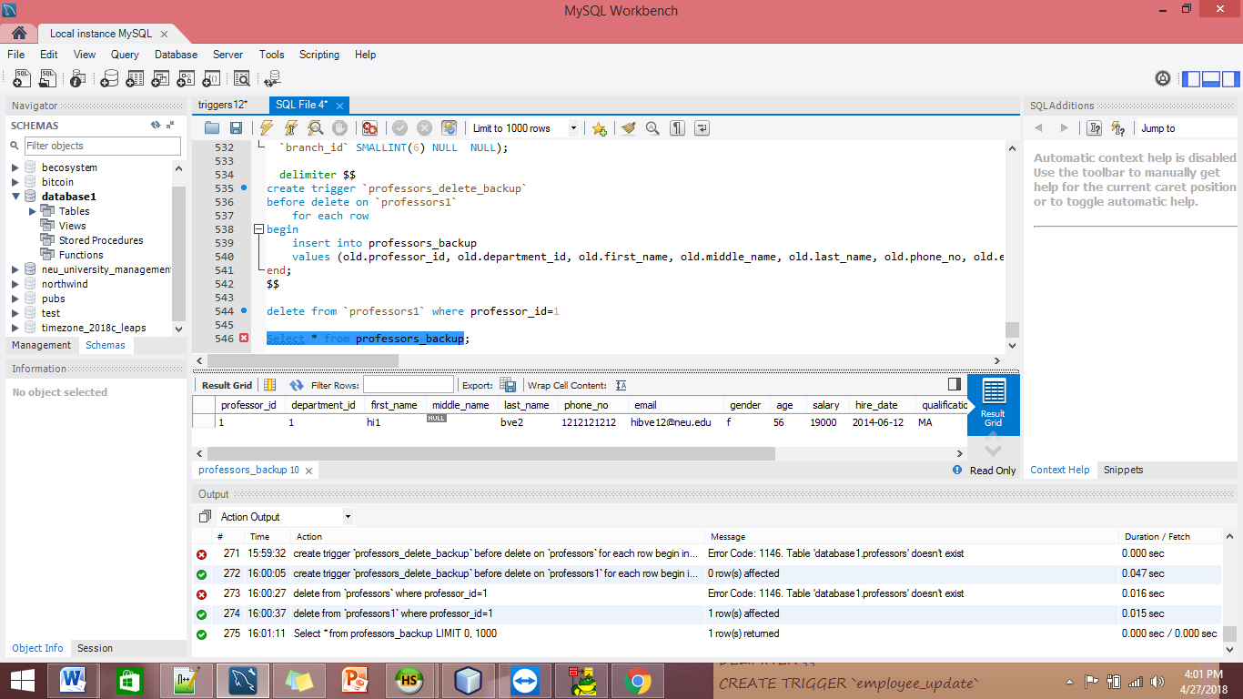

**VIEWS :**

CREATE VIEW StudentCourseSemister

AS

select s.first_name as student, c.course_name as course, c.semister as semister

from student1 s

inner join student_classes1 m ON s.student_id = m.student_id

inner join course1 c ON m.course_id = c.course_id

order by s.first_name;

select * from StudentCourseSemister

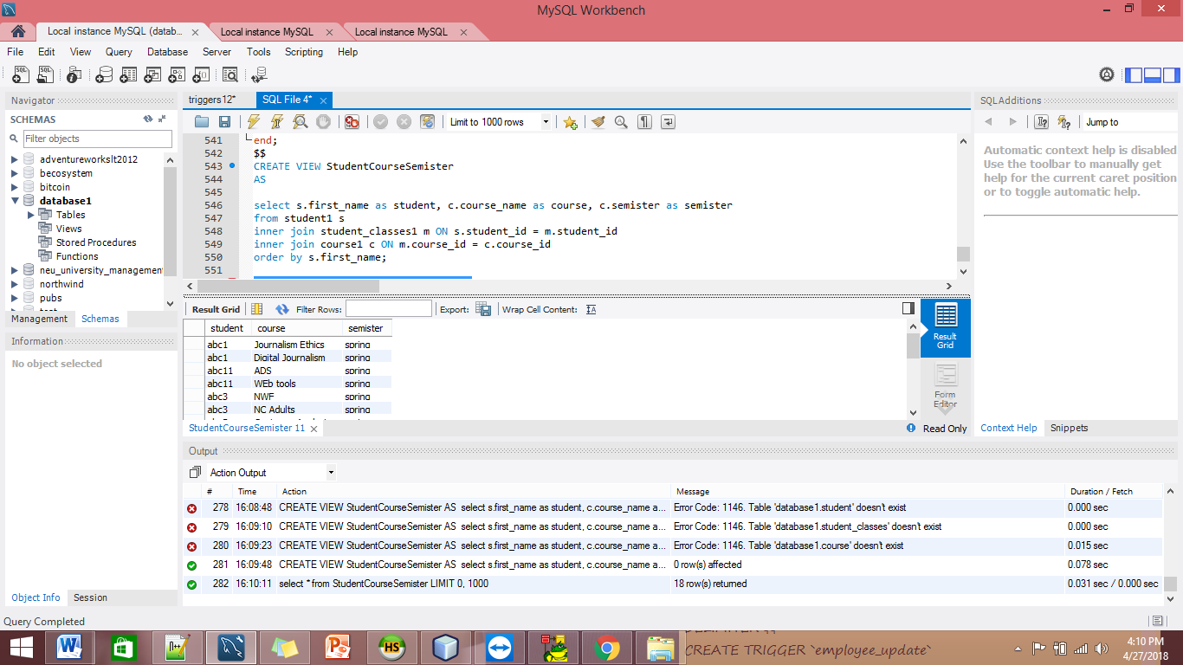

* To Find out Toppers:

CREATE VIEW Topper AS

SELECT

Student_id, course_id, grade_obtained,

FROM

grades_scored1

WHERE

grade_obtained = 'A';

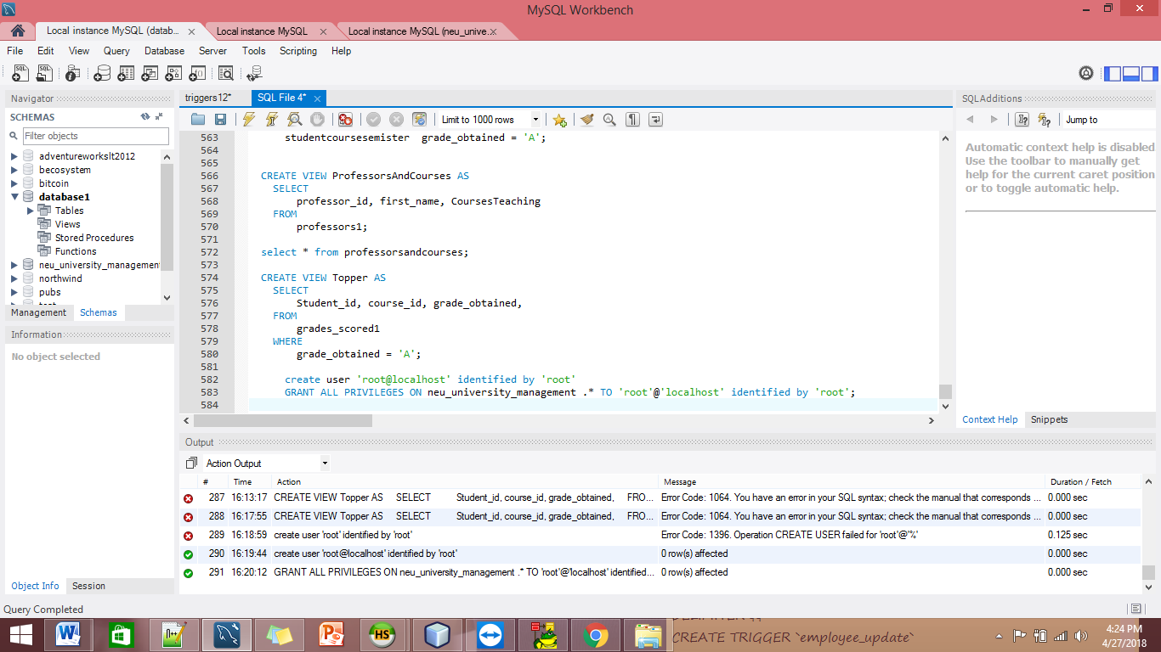

* view professorsandcourses

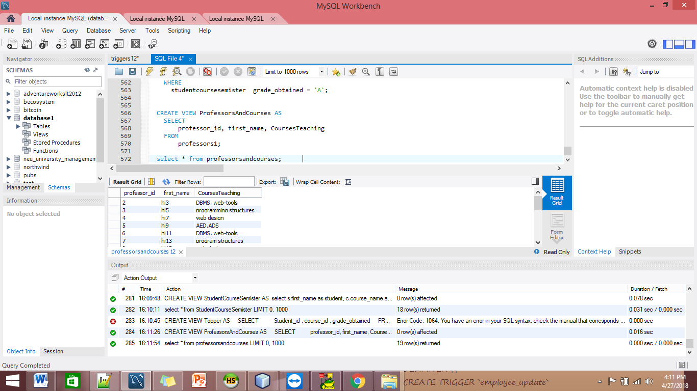

CREATE VIEW ProfessorsAndCourses AS

SELECT

professor_id, first_name, CoursesTeaching

FROM

professors1;

select * from professorsandcourses;

* GRANT PRIVILAGES:

CREATE VIEW ProfessorsAndCourses AS

SELECT

professor_id, first_name, CoursesTeaching

FROM

professors1;

select * from professorsandcourses;

**APPENDIX:**

create database database1;

use database1;

show tables;

CREATE TABLE Branch1

(

`branch_id` Smallint(6) NOT NULL AUTO_INCREMENT,

`Branch_Name` Varchar(50) NOT NULL,

`address_id` Int NOT NULL,

`Attribute1` Char(20),

PRIMARY KEY (`branch_id`)

)

;

drop table branch1;

Drop table branch1;

CREATE TABLE `Database1`.`Address1`

(

`address_id` Int NOT NULL AUTO_INCREMENT,

`branch_id` Smallint(6) NOT NULL,

`address` Varchar(60) NOT NULL,

PRIMARY KEY (`address_id`)

)

;

CREATE TABLE `Database1`.`Student1`

(

`Student_id` Smallint NOT NULL AUTO_INCREMENT,

`first_name` Char(20) NOT NULL,

`middle_name` Char(20),

`last_name` Char(20) NOT NULL,

`gender` Char(10) NOT NULL,

`department_id` Smallint NOT NULL,

`email` Varchar(30) NOT NULL,

`phone_no` Varchar(20) NOT NULL,

`parent_id` Smallint NOT NULL,

`enrollement_id` Smallint,

`CourseTakenTillDate` Varchar(200),

`semister` Varchar(20),

`Coop` Char(10),

`branch_id` Smallint(6),

PRIMARY KEY (`Student_id`),

UNIQUE `Student_id` (`Student_id`)

)

;

drop table student1;

CREATE TABLE `Database1`.`Parents1`

(

`Relationship` Char(15) NOT NULL,

`parent_id` Smallint NOT NULL AUTO_INCREMENT,

`Student_id` Smallint NOT NULL,

`first_name` Char(20) NOT NULL,

`middle_name` Char(20),

`last_name` Char(20) NOT NULL,

`phone_no` Varchar(20) NOT NULL,

`email_id` Varchar(30) NOT NULL,

`address` Varchar(60) NOT NULL,

`OtherParentDetails` Varchar(100),

PRIMARY KEY (`parent_id`),

UNIQUE `parent_id` (`parent_id`)

)

;

CREATE TABLE `Database1`.`Professors1`

(

`professor_id` Smallint NOT NULL AUTO_INCREMENT,

`department_id` Smallint NOT NULL,

`first_name` Char(20) NOT NULL,

`middle_name` Char(20),

`last_name` Char(20) NOT NULL,

`phone_no` Varchar(20) NOT NULL,

`email` Varchar(30) NOT NULL,

`gender` Char(10),

`age` Smallint,

`salary` Int,

`hire_date` Date,

`qualification` Varchar(30),

`CoursesTeaching` Varchar(50),

`otherDetails` Varchar(100),

`branch_id` Smallint(6),

PRIMARY KEY (`professor_id`),

UNIQUE `Professor_id` (`professor_id`)

)

;

CREATE TABLE `Database1`.`Dean1`

(

`dean_id` Smallint NOT NULL AUTO_INCREMENT,

`department_id` Smallint NOT NULL,

`name` Char(30) NOT NULL,

`professor_id` Smallint NOT NULL,

PRIMARY KEY (`dean_id`)

)

;

CREATE TABLE `Database1`.`Department1`

(

`department_id` Smallint NOT NULL AUTO_INCREMENT,

`department_name` varchar(50) NOT NULL,

`address_id` Int,

`dean_id` Smallint NOT NULL,

`other_details` Varchar(50) NOT NULL,

`branch_id` Int,

PRIMARY KEY (`department_id`),

UNIQUE `Department_id` (`department_id`)

)

;

drop table department1;

CREATE TABLE `Database1`.`Course1`

(

`course_id` Smallint NOT NULL AUTO_INCREMENT,

`course_name` Varchar(30) NOT NULL,

`department_id` Smallint NOT NULL,

`type` Char(20) NOT NULL,

`semister` Char(20),

`branch_id` Smallint(6),

PRIMARY KEY (`course_id`)

)

;

CREATE TABLE `Database1`.`Classes1`

(

`class_id` Smallint NOT NULL AUTO_INCREMENT,

`course_id` Smallint NOT NULL,

`professor_id` Smallint,

`department_id` Smallint NOT NULL,

`class_code` Varchar(20),

`date_from` Date,

`date_to` Date,

`room_no` Varchar(20),

`branch_id` Smallint(6),

PRIMARY KEY (`class_id`)

)

;

CREATE TABLE `Database1`.`Student_classes1`

(

`Student_id` Smallint NOT NULL,

`class_id` Smallint NOT NULL,

`course_id` Smallint NOT NULL,

`term` Char(20),

`date_to` Date,

`date_from` Date

)

;

CREATE TABLE `Database1`.`Enrollement1`

(

`enrollement_id` Smallint NOT NULL AUTO_INCREMENT,

`name` Varchar(30) NOT NULL,

`Student_id` Smallint NOT NULL,

`present_term` Varchar(20),

`date_enrolled` Date,

`term_enrolled` Char(20),

`department_id` Smallint,

`branch_id` Smallint(6),

PRIMARY KEY (`enrollement_id`)

)

;

CREATE TABLE `Database1`.`Grades_Scored1`

(

`Student_id` Smallint NOT NULL,

`course_id` Smallint NOT NULL,

`professor_id` Smallint NOT NULL,

`semister` Char(20),

`grade_obtained` Char(20) NOT NULL

)

;

CREATE TABLE `Database1`.`Student_Parent1`

(

`Student_id` Smallint NOT NULL,

`parent_id` Smallint NOT NULL

)

;

show tables;

-- -----------------------------------------------------

-- Data for table `database1`.`branch`

-- -----------------------------------------------------

START TRANSACTION;

USE `database1`;

INSERT INTO `database1`.`branch1` (`branch_id`, `Branch_Name`, `address_id`) VALUES (1, 'Boston', 1);

INSERT INTO `database1`.`branch1` (`branch_id`, `Branch_Name`, `address_id`) VALUES (2, 'Seattle', 2);

INSERT INTO `database1`.`branch1` (`branch_id`, `Branch_Name`, `address_id`) VALUES (3, 'Silicon Valley', 3);

COMMIT;

-- -----------------------------------------------------

-- Data for table `database1`.`address`

-- -----------------------------------------------------

START TRANSACTION;

USE `database1`;

INSERT INTO `database1`.`address1` (`address_id`, `branch_id`, `address`) VALUES (1, 1, '360 Huntington Ave, Boston, MA 02115');

INSERT INTO `database1`.`address1` (`address_id`, `branch_id`, `address`) VALUES (2, 2, '401 Terry Ave N #103, Seattle, WA 98109');

INSERT INTO `database1`.`address1` (`address_id`, `branch_id`, `address`) VALUES (3, 3, '6024 Silver Creek Valley Rd, San Jose, CA 95138');

COMMIT;

-- -----------------------------------------------------

-- Data for table `database1`.`professors`

-- -----------------------------------------------------

START TRANSACTION;

USE `database1`;

INSERT INTO `database1`.`professors1` (`professor_id`, `department_id`, `first_name`, `middle_name`, `last_name`, `phone_no`, `email`, `gender`, `age`, `salary`, `hire_date`, `qualification`, `CoursesTeaching`, `otherDetails`, `branch_id`) VALUES (1, 1, 'hi1', NULL, 'bye2', '1212121212', 'hibye12@neu.edu', 'f', 56, 19000, '2014-06-12 ', 'MA', 'AED', NULL, 1);

INSERT INTO `database1`.`professors1` (`professor_id`, `department_id`, `first_name`, `middle_name`, `last_name`, `phone_no`, `email`, `gender`, `age`, `salary`, `hire_date`, `qualification`, `CoursesTeaching`, `otherDetails`, `branch_id`) VALUES (2, 1, 'hi3', NULL, 'bye4', '2323232323', 'hibye34@neu.edu', 'f', 34, 15000, '2011-06-29 ', 'MS', 'DBMS, web-tools', NULL, 1);

INSERT INTO `database1`.`professors1` (`professor_id`, `department_id`, `first_name`, `middle_name`, `last_name`, `phone_no`, `email`, `gender`, `age`, `salary`, `hire_date`, `qualification`, `CoursesTeaching`, `otherDetails`, `branch_id`) VALUES (3, 1, 'hi5', NULL, 'bye6', '3434343434', 'hibye56@neu.edu', 'm', 77, 17000, '1996-07-22 ', 'Phd', 'programming structures', NULL, 1);

INSERT INTO `database1`.`professors1` (`professor_id`, `department_id`, `first_name`, `middle_name`, `last_name`, `phone_no`, `email`, `gender`, `age`, `salary`, `hire_date`, `qualification`, `CoursesTeaching`, `otherDetails`, `branch_id`) VALUES (4, 1, 'hi7', NULL, 'bye8', '4545454545', 'hibye78@neu.edu', 'm', 44, 12000, '2014-07-22 ', 'MA', 'web design', NULL, 1);

INSERT INTO `database1`.`professors1` (`professor_id`, `department_id`, `first_name`, `middle_name`, `last_name`, `phone_no`, `email`, `gender`, `age`, `salary`, `hire_date`, `qualification`, `CoursesTeaching`, `otherDetails`, `branch_id`) VALUES (5, 2, 'hi9', 'd', 'bye10', '5656565656', 'hibye910@neu.edu', 'm', 27, 7000, '2014-07-22 ', 'Phd', 'AED,ADS', NULL, 3);

INSERT INTO `database1`.`professors1` (`professor_id`, `department_id`, `first_name`, `middle_name`, `last_name`, `phone_no`, `email`, `gender`, `age`, `salary`, `hire_date`, `qualification`, `CoursesTeaching`, `otherDetails`, `branch_id`) VALUES (6, 2, 'hi11', NULL, 'bye12', '6767676767', 'hibye1112@neu.edu', 'm', 32, 9000, '2015-07-20 ', 'MA', 'DBMS, web-tools', NULL, 3);

INSERT INTO `database1`.`professors1` (`professor_id`, `department_id`, `first_name`, `middle_name`, `last_name`, `phone_no`, `email`, `gender`, `age`, `salary`, `hire_date`, `qualification`, `CoursesTeaching`, `otherDetails`, `branch_id`) VALUES (7, 2, 'hi13', 'cx', 'bye14', '7878787878', 'hibye1314@neu.edu', 'm', 56, 14000, '2002-01-26 ', 'Phd', 'program structures', NULL, 3);

INSERT INTO `database1`.`professors1` (`professor_id`, `department_id`, `first_name`, `middle_name`, `last_name`, `phone_no`, `email`, `gender`, `age`, `salary`, `hire_date`, `qualification`, `CoursesTeaching`, `otherDetails`, `branch_id`) VALUES (8, 2, 'hi15', NULL, 'bye16', '8989898989', 'hibye1516@neu.edu', 'm', 76, 20000, '1995-02-20 ', 'Phd', 'web design', NULL, 3);

INSERT INTO `database1`.`professors1` (`professor_id`, `department_id`, `first_name`, `middle_name`, `last_name`, `phone_no`, `email`, `gender`, `age`, `salary`, `hire_date`, `qualification`, `CoursesTeaching`, `otherDetails`, `branch_id`) VALUES (9, 3, 'hi17', 'thg', 'bye18', '9090909090', 'hibye1718@neu.edu', 'm', 34, 5000, '2011-03-11 ', 'Phd', 'Business Analytics', NULL, 1);

INSERT INTO `database1`.`professors1` (`professor_id`, `department_id`, `first_name`, `middle_name`, `last_name`, `phone_no`, `email`, `gender`, `age`, `salary`, `hire_date`, `qualification`, `CoursesTeaching`, `otherDetails`, `branch_id`) VALUES (10, 3, 'hi19', 'qwq', 'bye20', '0909090909', 'hibye1920@neu.edu', 'm', 56, 11000, '1997-08-20', 'MA', 'Data Analysis', NULL, 1);

INSERT INTO `database1`.`professors1` (`professor_id`, `department_id`, `first_name`, `middle_name`, `last_name`, `phone_no`, `email`, `gender`, `age`, `salary`, `hire_date`, `qualification`, `CoursesTeaching`, `otherDetails`, `branch_id`) VALUES (11, 3, 'hi21', 'uiui', 'bye22', '9898989898', 'hibye2122@neu.edu', 'f', 56, 11000, '1997-04-22 ', 'ms', 'BAM', NULL, 1);

INSERT INTO `database1`.`professors1` (`professor_id`, `department_id`, `first_name`, `middle_name`, `last_name`, `phone_no`, `email`, `gender`, `age`, `salary`, `hire_date`, `qualification`, `CoursesTeaching`, `otherDetails`, `branch_id`) VALUES (12, 3, 'hi23', NULL, 'bye24', '8787878787', 'hibye2324@neu.edu', 'm', 44, 6000, '2015-07-25', 'ms', 'Customer Analysis', NULL, 1);

INSERT INTO `database1`.`professors1` (`professor_id`, `department_id`, `first_name`, `middle_name`, `last_name`, `phone_no`, `email`, `gender`, `age`, `salary`, `hire_date`, `qualification`, `CoursesTeaching`, `otherDetails`, `branch_id`) VALUES (13, 4, 'hi25', NULL, 'bye26', '7676767676', 'hibye2526@neu.edu', 'm', 29, 4000, '2016-07-26', 'Phd', 'Business Analytics', NULL, 2);

INSERT INTO `database1`.`professors1` (`professor_id`, `department_id`, `first_name`, `middle_name`, `last_name`, `phone_no`, `email`, `gender`, `age`, `salary`, `hire_date`, `qualification`, `CoursesTeaching`, `otherDetails`, `branch_id`) VALUES (14, 4, 'hi27', NULL, 'bye28', '6565656565', 'hibye2728@neu.edu', 'm', 47, 13000, '2000-07-09', 'Phd', 'Data Analysis', NULL, 2);

INSERT INTO `database1`.`professors1` (`professor_id`, `department_id`, `first_name`, `middle_name`, `last_name`, `phone_no`, `email`, `gender`, `age`, `salary`, `hire_date`, `qualification`, `CoursesTeaching`, `otherDetails`, `branch_id`) VALUES (15, 4, 'hi29', 'sdsf', 'bye30', '5454545454', 'hibye2930@neu.edu', 'm', 39, 10000, '2014-03-10', 'ma', 'BAM', NULL, 2);

INSERT INTO `database1`.`professors1` (`professor_id`, `department_id`, `first_name`, `middle_name`, `last_name`, `phone_no`, `email`, `gender`, `age`, `salary`, `hire_date`, `qualification`, `CoursesTeaching`, `otherDetails`, `branch_id`) VALUES (16, 4, 'hi31', NULL, 'bye32', '4343434343', 'hibye3132@neu.edu', 'f', 42, 14000, '2013-07-23', 'ma', 'Customer Analysis', NULL, 2);

INSERT INTO `database1`.`professors1` (`professor_id`, `department_id`, `first_name`, `middle_name`, `last_name`, `phone_no`, `email`, `gender`, `age`, `salary`, `hire_date`, `qualification`, `CoursesTeaching`, `otherDetails`, `branch_id`) VALUES (17, 5, 'hi33', 'foo', 'bye34', '3232323232', 'hibye3334@neu.edu', 'f', 45, 15000, '2014-07-22 ', 'Phd', 'NWF', NULL, 1);

INSERT INTO `database1`.`professors1` (`professor_id`, `department_id`, `first_name`, `middle_name`, `last_name`, `phone_no`, `email`, `gender`, `age`, `salary`, `hire_date`, `qualification`, `CoursesTeaching`, `otherDetails`, `branch_id`) VALUES (18, 5, 'hi35', NULL, 'bye36', '2121212121', 'hibye3536@neu.edu', 'm', 32, 14000, '2011-07-22 ', 'Phd', 'NCA', NULL, 1);

INSERT INTO `database1`.`professors1` (`professor_id`, `department_id`, `first_name`, `middle_name`, `last_name`, `phone_no`, `email`, `gender`, `age`, `salary`, `hire_date`, `qualification`, `CoursesTeaching`, `otherDetails`, `branch_id`) VALUES (19, 7, 'hi37', 'all', 'bye38', '3333333333', 'hibye3738@neu.edu', 'm', 45, 18000, '2014-07-22 ', 'Phd', 'Enterprise Reporting 1,Enterprise Reporting 2', NULL, 3);

INSERT INTO `database1`.`professors1` (`professor_id`, `department_id`, `first_name`, `middle_name`, `last_name`, `phone_no`, `email`, `gender`, `age`, `salary`, `hire_date`, `qualification`, `CoursesTeaching`, `otherDetails`, `branch_id`) VALUES (20, 7, 'hi39', 'giiii', 'bye40', '4444444444', 'hibye3940@neu.edu', 'm', 33, 16000, '2011-05-12 ', 'ms', 'Journalism Ethics,Digital Journalism', NULL, 3);

COMMIT;

-- -----------------------------------------------------

-- Data for table `database1`.`dean`

-- -----------------------------------------------------

START TRANSACTION;

USE `database1`;

INSERT INTO `database1`.`dean1` (`dean_id`, `department_id`, `name`, `professor_id`) VALUES (1, 1, 'hi3', 2);

INSERT INTO `database1`.`dean1` (`dean_id`, `department_id`, `name`, `professor_id`) VALUES (2, 2, 'hi11', 6);

INSERT INTO `database1`.`dean1` (`dean_id`, `department_id`, `name`, `professor_id`) VALUES (3, 3, 'hi17', 9);

INSERT INTO `database1`.`dean1` (`dean_id`, `department_id`, `name`, `professor_id`) VALUES (4, 4, 'hi29', 15);

INSERT INTO `database1`.`dean1` (`dean_id`, `department_id`, `name`, `professor_id`) VALUES (5, 5, 'hi35', 18);

INSERT INTO `database1`.`dean1` (`dean_id`, `department_id`, `name`, `professor_id`) VALUES (6, 6, 'hi25', 13);

INSERT INTO `database1`.`dean1` (`dean_id`, `department_id`, `name`, `professor_id`) VALUES (7, 7, 'hi37', 19);

INSERT INTO `database1`.`dean1` (`dean_id`, `department_id`, `name`, `professor_id`) VALUES (8, 8, 'hi13', 7);

COMMIT;

-- -----------------------------------------------------

-- Data for table `database1`.`department1`

-- -----------------------------------------------------

START TRANSACTION;

USE `database1`;

INSERT INTO `database1`.`department1` (`department_id`, `department_name`, `address_id`, `dean_id`, `other_details`, `branch_id`) VALUES (1, 'engineering', 1, 1, 'nodetails' , 1);

INSERT INTO `database1`.`department1` (`department_id`, `department_name`, `address_id`, `dean_id`, `other_details`, `branch_id`) VALUES (2, 'engineering', 3, 2, 'nodetails', 3);

INSERT INTO `database1`.`department1` (`department_id`, `department_name`, `address_id`, `dean_id`, `other_details`, `branch_id`) VALUES (3, 'business', 1, 3, 'nodetails', 1);

INSERT INTO `database1`.`department1` (`department_id`, `department_name`, `address_id`, `dean_id`, `other_details`, `branch_id`) VALUES (4, 'business', 2, 4, 'nodetails', 2);

INSERT INTO `database1`.`department1` (`department_id`, `department_name`, `address_id`, `dean_id`, `other_details`, `branch_id`) VALUES (5, 'nursing', 1, 5, 'nodetails', 1);

INSERT INTO `database1`.`department1` (`department_id`, `department_name`, `address_id`, `dean_id`, `other_details`, `branch_id`) VALUES (6, 'nursing', 2, 6, 'nodetails', 2);

INSERT INTO `database1`.`department1` (`department_id`, `department_name`, `address_id`, `dean_id`, `other_details`, `branch_id`) VALUES (7, 'journalism', 3, 7, 'nodetails', 3);

INSERT INTO `database1`.`department1` (`department_id`, `department_name`, `address_id`, `dean_id`, `other_details`, `branch_id`) VALUES (8, 'education', 2, 8, 'nodetails', 2);

COMMIT;

-- -----------------------------------------------------

-- Data for table `database1`.`course`

-- -----------------------------------------------------

START TRANSACTION;

USE `database1`;

INSERT INTO `database1`.`course1` (`course_id`, `course_name`, `department_id`, `type`, `semister`, `branch_id`) VALUES (1, 'AED', 1, 'traditional', 'spring', 1);

INSERT INTO `database1`.`course1` (`course_id`, `course_name`, `department_id`, `type`, `semister`, `branch_id`) VALUES (2, 'DBMS', 1, 'traditional', 'spring', 1);

INSERT INTO `database1`.`course1` (`course_id`, `course_name`, `department_id`, `type`, `semister`, `branch_id`) VALUES (3, 'ADS', 1, 'traditional', 'spring', 1);

INSERT INTO `database1`.`course1` (`course_id`, `course_name`, `department_id`, `type`, `semister`, `branch_id`) VALUES (4, 'WEb tools', 1, 'traditional', 'spring', 1);

INSERT INTO `database1`.`course1` (`course_id`, `course_name`, `department_id`, `type`, `semister`, `branch_id`) VALUES (5, 'programing structures', 1, 'traditional', 'spring', 1);

INSERT INTO `database1`.`course1` (`course_id`, `course_name`, `department_id`, `type`, `semister`, `branch_id`) VALUES (6, 'AED', 2, 'traditional', 'spring', 3);

INSERT INTO `database1`.`course1` (`course_id`, `course_name`, `department_id`, `type`, `semister`, `branch_id`) VALUES (7, 'dbms', 2, 'traditional', 'spring', 3);

INSERT INTO `database1`.`course1` (`course_id`, `course_name`, `department_id`, `type`, `semister`, `branch_id`) VALUES (8, 'ads', 2, 'online', 'spring', 3);

INSERT INTO `database1`.`course1` (`course_id`, `course_name`, `department_id`, `type`, `semister`, `branch_id`) VALUES (9, 'web tools', 2, 'traditional', 'spring', 3);

INSERT INTO `database1`.`course1` (`course_id`, `course_name`, `department_id`, `type`, `semister`, `branch_id`) VALUES (10, 'programming structures', 2, 'traditional', 'spring', 3);

INSERT INTO `database1`.`course1` (`course_id`, `course_name`, `department_id`, `type`, `semister`, `branch_id`) VALUES (11, 'Business Analytics', 3, 'traditional', 'spring', 1);

INSERT INTO `database1`.`course1` (`course_id`, `course_name`, `department_id`, `type`, `semister`, `branch_id`) VALUES (12, ' Data Analysis', 3, 'traditional', 'spring', 1);

INSERT INTO `database1`.`course1` (`course_id`, `course_name`, `department_id`, `type`, `semister`, `branch_id`) VALUES (13, 'BAM', 3, 'traditional', 'spring', 1);

INSERT INTO `database1`.`course1` (`course_id`, `course_name`, `department_id`, `type`, `semister`, `branch_id`) VALUES (14, 'Customer Analysis', 3, 'traditional', 'spring', 1);

INSERT INTO `database1`.`course1` (`course_id`, `course_name`, `department_id`, `type`, `semister`, `branch_id`) VALUES (15, 'Business Analytics', 4, 'online', 'spring', 3);

INSERT INTO `database1`.`course1` (`course_id`, `course_name`, `department_id`, `type`, `semister`, `branch_id`) VALUES (16, ' Data Analysis', 4, 'online', 'spring', 3);

INSERT INTO `database1`.`course1` (`course_id`, `course_name`, `department_id`, `type`, `semister`, `branch_id`) VALUES (17, 'BAM', 4, 'online', 'spring', 3);

INSERT INTO `database1`.`course1` (`course_id`, `course_name`, `department_id`, `type`, `semister`, `branch_id`) VALUES (18, 'Customer Analysis', 4, 'online', 'spring', 3);

INSERT INTO `database1`.`course1` (`course_id`, `course_name`, `department_id`, `type`, `semister`, `branch_id`) VALUES (19, 'Nursing Perspective', 5, 'traditional', 'spring', 1);

INSERT INTO `database1`.`course1` (`course_id`, `course_name`, `department_id`, `type`, `semister`, `branch_id`) VALUES (20, 'Nursing Interventions', 5, 'traditional', 'spring', 1);

INSERT INTO `database1`.`course1` (`course_id`, `course_name`, `department_id`, `type`, `semister`, `branch_id`) VALUES (21, 'NWF', 5, 'traditional', 'spring', 1);

INSERT INTO `database1`.`course1` (`course_id`, `course_name`, `department_id`, `type`, `semister`, `branch_id`) VALUES (22, 'NC Adults', 5, 'traditional', 'spring', 1);

INSERT INTO `database1`.`course1` (`course_id`, `course_name`, `department_id`, `type`, `semister`, `branch_id`) VALUES (23, 'Enterprise Reporting 1', 7, 'online', 'spring', 3);

INSERT INTO `database1`.`course1` (`course_id`, `course_name`, `department_id`, `type`, `semister`, `branch_id`) VALUES (24, 'Enterprise Reporting 2', 7, 'online', 'spring', 3);

INSERT INTO `database1`.`course1` (`course_id`, `course_name`, `department_id`, `type`, `semister`, `branch_id`) VALUES (25, 'Journalism Ethics', 7, 'online', 'spring', 3);

INSERT INTO `database1`.`course1` (`course_id`, `course_name`, `department_id`, `type`, `semister`, `branch_id`) VALUES (26, 'Digital Journalism', 7, 'online', 'spring', 3);

COMMIT;

-- -----------------------------------------------------

-- Data for table `database1`.`classes`

-- -----------------------------------------------------

START TRANSACTION;

USE `database1`;

INSERT INTO `database1`.`classes1` (`class_id`, `course_id`, `professor_id`, `department_id`, `class_code`, `date_from`, `date_to`, `room_no`, `branch_id`) VALUES (1, 1, 1, 1, '001', '2018-01-07', '2018-04-27', '111', 1);

INSERT INTO `database1`.`classes1` (`class_id`, `course_id`, `professor_id`, `department_id`, `class_code`, `date_from`, `date_to`, `room_no`, `branch_id`) VALUES (2, 2, 2, 1, '002', '2018-01-07', '2018-04-27', '112', 1);

INSERT INTO `database1`.`classes1` (`class_id`, `course_id`, `professor_id`, `department_id`, `class_code`, `date_from`, `date_to`, `room_no`, `branch_id`) VALUES (3, 3, 1, 1, '003', '2018-01-07', '2018-04-27', '113', 1);

INSERT INTO `database1`.`classes1` (`class_id`, `course_id`, `professor_id`, `department_id`, `class_code`, `date_from`, `date_to`, `room_no`, `branch_id`) VALUES (4, 4, 2, 1, '004', '2018-01-07', '2018-04-27', '114', 1);

INSERT INTO `database1`.`classes1` (`class_id`, `course_id`, `professor_id`, `department_id`, `class_code`, `date_from`, `date_to`, `room_no`, `branch_id`) VALUES (5, 5, 3, 1, '005', '2018-01-07', '2018-04-27', '115', 1);

INSERT INTO `database1`.`classes1` (`class_id`, `course_id`, `professor_id`, `department_id`, `class_code`, `date_from`, `date_to`, `room_no`, `branch_id`) VALUES (6, 6, 5, 2, '006', '2018-01-07', '2018-04-27', '311', 3);

INSERT INTO `database1`.`classes1` (`class_id`, `course_id`, `professor_id`, `department_id`, `class_code`, `date_from`, `date_to`, `room_no`, `branch_id`) VALUES (7, 7, 6, 2, '007', '2018-01-07', '2018-04-27', '312', 3);

INSERT INTO `database1`.`classes1` (`class_id`, `course_id`, `professor_id`, `department_id`, `class_code`, `date_from`, `date_to`, `room_no`, `branch_id`) VALUES (8, 8, 5, 2, '008', '2018-01-07', '2018-04-27', 'online', 3);

INSERT INTO `database1`.`classes1` (`class_id`, `course_id`, `professor_id`, `department_id`, `class_code`, `date_from`, `date_to`, `room_no`, `branch_id`) VALUES (9, 9, 6, 2, '009', '2018-01-07', '2018-04-27', '313', 3);

INSERT INTO `database1`.`classes1` (`class_id`, `course_id`, `professor_id`, `department_id`, `class_code`, `date_from`, `date_to`, `room_no`, `branch_id`) VALUES (10, 10, 7, 2, '010', '2018-01-07', '2018-04-27', '314', 3);

INSERT INTO `database1`.`classes1` (`class_id`, `course_id`, `professor_id`, `department_id`, `class_code`, `date_from`, `date_to`, `room_no`, `branch_id`) VALUES (11, 11, 9, 3, '011', '2018-01-07', '2018-04-27', '116', 1);

INSERT INTO `database1`.`classes1` (`class_id`, `course_id`, `professor_id`, `department_id`, `class_code`, `date_from`, `date_to`, `room_no`, `branch_id`) VALUES (12, 12, 10, 3, '012', '2018-01-07', '2018-04-27', '117', 1);

INSERT INTO `database1`.`classes1` (`class_id`, `course_id`, `professor_id`, `department_id`, `class_code`, `date_from`, `date_to`, `room_no`, `branch_id`) VALUES (13, 13, 11, 3, '013', '2018-01-07', '2018-04-27', '118', 1);

INSERT INTO `database1`.`classes1` (`class_id`, `course_id`, `professor_id`, `department_id`, `class_code`, `date_from`, `date_to`, `room_no`, `branch_id`) VALUES (14, 14, 12, 3, '014', '2018-01-07', '2018-04-27', '119', 1);

INSERT INTO `database1`.`classes1` (`class_id`, `course_id`, `professor_id`, `department_id`, `class_code`, `date_from`, `date_to`, `room_no`, `branch_id`) VALUES (15, 15, 13, 3, '015', '2018-01-07', '2018-04-27', 'online', 3);

INSERT INTO `database1`.`classes1` (`class_id`, `course_id`, `professor_id`, `department_id`, `class_code`, `date_from`, `date_to`, `room_no`, `branch_id`) VALUES (16, 16, 14, 3, '016', '2018-01-07', '2018-04-27', 'online', 3);

INSERT INTO `database1`.`classes1` (`class_id`, `course_id`, `professor_id`, `department_id`, `class_code`, `date_from`, `date_to`, `room_no`, `branch_id`) VALUES (17, 17, 15, 3, '017', '2018-01-07', '2018-04-27', 'online', 3);

INSERT INTO `database1`.`classes1` (`class_id`, `course_id`, `professor_id`, `department_id`, `class_code`, `date_from`, `date_to`, `room_no`, `branch_id`) VALUES (18, 18, 16, 3, '018', '2018-01-07', '2018-04-27', 'online', 3);

INSERT INTO `database1`.`classes1` (`class_id`, `course_id`, `professor_id`, `department_id`, `class_code`, `date_from`, `date_to`, `room_no`, `branch_id`) VALUES (19, 19, 17, 5, '019', '2018-01-07', '2018-04-27', '120', 1);

INSERT INTO `database1`.`classes1` (`class_id`, `course_id`, `professor_id`, `department_id`, `class_code`, `date_from`, `date_to`, `room_no`, `branch_id`) VALUES (20, 20, 18, 5, '020', '2018-01-07', '2018-04-27', '121', 1);

INSERT INTO `database1`.`classes1` (`class_id`, `course_id`, `professor_id`, `department_id`, `class_code`, `date_from`, `date_to`, `room_no`, `branch_id`) VALUES (21, 21, 17, 5, '021', '2018-01-07', '2018-04-27', '122', 1);

INSERT INTO `database1`.`classes1` (`class_id`, `course_id`, `professor_id`, `department_id`, `class_code`, `date_from`, `date_to`, `room_no`, `branch_id`) VALUES (22, 22, 18, 5, '022', '2018-01-07', '2018-04-27', '123', 1);

INSERT INTO `database1`.`classes1` (`class_id`, `course_id`, `professor_id`, `department_id`, `class_code`, `date_from`, `date_to`, `room_no`, `branch_id`) VALUES (23, 23, 20, 7, '023', '2018-01-07', '2018-04-27', 'online', 3);

INSERT INTO `database1`.`classes1` (`class_id`, `course_id`, `professor_id`, `department_id`, `class_code`, `date_from`, `date_to`, `room_no`, `branch_id`) VALUES (24, 24, 20, 7, '024', '2018-01-07', '2018-04-27', 'online', 3);

INSERT INTO `database1`.`classes1` (`class_id`, `course_id`, `professor_id`, `department_id`, `class_code`, `date_from`, `date_to`, `room_no`, `branch_id`) VALUES (25, 25, 20, 7, '025', '2018-01-07', '2018-04-27', 'online', 3);

INSERT INTO `database1`.`classes1` (`class_id`, `course_id`, `professor_id`, `department_id`, `class_code`, `date_from`, `date_to`, `room_no`, `branch_id`) VALUES (26, 26, 20, 7, '026', '2018-01-07', '2018-04-27', 'online', 3);

COMMIT;

-- -----------------------------------------------------

-- Data for table `database1`.`student`

-- -----------------------------------------------------

START TRANSACTION;

USE `database1`;

INSERT INTO `database1`.`student1` (`Student_id`, `first_name`, `middle_name`, `last_name`, `gender`, `department_id`, `email`, `phone_no`, `parent_id`, `enrollement_id`, `CourseTakenTillDate`, `semister`, `Co-op`, `branch_id`) VALUES (10, 'abc13', '', 'abc14', 'female', 2, 'abc1314@neu.edu', '8767878787', 10, 10, 'AED,DBSMS', 'summer', 'no', 3);

COMMIT;

-- -----------------------------------------------------

-- Data for table `database1`.`enrollement`

-- -----------------------------------------------------

START TRANSACTION;

USE `database1`;

INSERT INTO `database1`.`enrollement1` (`enrollement_id`, `name`, `Student_id`, `present_term`, `date_enrolled`, `term_enrolled`, `department_id`, `branch_id`) VALUES (1, 'spoorthi', 1, 'Spring', '2017-06-10', 'fall', 3, 1);

INSERT INTO `database1`.`enrollement1` (`enrollement_id`, `name`, `Student_id`, `present_term`, `date_enrolled`, `term_enrolled`, `department_id`, `branch_id`) VALUES (2, 'kanika', 2, 'Spring', '2017-06-10', 'fall', 1, 1);

INSERT INTO `database1`.`enrollement1` (`enrollement_id`, `name`, `Student_id`, `present_term`, `date_enrolled`, `term_enrolled`, `department_id`, `branch_id`) VALUES (3, 'priyanshi', 3, 'Spring', '2017-06-10', 'summer', 2, 3);

INSERT INTO `database1`.`enrollement1` (`enrollement_id`, `name`, `Student_id`, `present_term`, `date_enrolled`, `term_enrolled`, `department_id`, `branch_id`) VALUES (4, 'abc1', 4, 'Spring', '2017-06-10', 'fall', 7, 3);

INSERT INTO `database1`.`enrollement1` (`enrollement_id`, `name`, `Student_id`, `present_term`, `date_enrolled`, `term_enrolled`, `department_id`, `branch_id`) VALUES (5, 'abc3', 5, 'Spring', '2017-06-10', 'fall', 5, 1);

INSERT INTO `database1`.`enrollement1` (`enrollement_id`, `name`, `Student_id`, `present_term`, `date_enrolled`, `term_enrolled`, `department_id`, `branch_id`) VALUES (6, 'abc5', 6, 'Spring', '2017-06-10', 'summer', 4, 2);

INSERT INTO `database1`.`enrollement1` (`enrollement_id`, `name`, `Student_id`, `present_term`, `date_enrolled`, `term_enrolled`, `department_id`, `branch_id`) VALUES (7, 'abc7', 7, 'Spring', '2017-06-10', 'fall', 1, 1);

INSERT INTO `database1`.`enrollement1` (`enrollement_id`, `name`, `Student_id`, `present_term`, `date_enrolled`, `term_enrolled`, `department_id`, `branch_id`) VALUES (8, 'abc9', 8, 'Spring', '2017-06-10', 'summer', 1, 1);

INSERT INTO `database1`.`enrollement1` (`enrollement_id`, `name`, `Student_id`, `present_term`, `date_enrolled`, `term_enrolled`, `department_id`, `branch_id`) VALUES (9, 'abc11', 9, 'Spring', '2017-06-10', 'fall', 1, 1);

INSERT INTO `database1`.`enrollement1` (`enrollement_id`, `name`, `Student_id`, `present_term`, `date_enrolled`, `term_enrolled`, `department_id`, `branch_id`) VALUES (10, 'abc13', 10, 'Spring', '2017-06-10', 'fall', 2, 3);

COMMIT;

-- -----------------------------------------------------

-- Data for table `database1`.`grades_scored`

-- -----------------------------------------------------

START TRANSACTION;

USE `database1`;

INSERT INTO `database1`.`grades_scored1` (`Student_id`, `course_id`, `professor_id`, `semister`, `grade_obtained`) VALUES (1, 11, 9, 'FALL', 'A');

INSERT INTO `database1`.`grades_scored1` (`Student_id`, `course_id`, `professor_id`, `semister`, `grade_obtained`) VALUES (1, 12, 10, 'FALL', 'A');

INSERT INTO `database1`.`grades_scored1` (`Student_id`, `course_id`, `professor_id`, `semister`, `grade_obtained`) VALUES (2, 1, 1, 'FALL', 'B');

INSERT INTO `database1`.`grades_scored1` (`Student_id`, `course_id`, `professor_id`, `semister`, `grade_obtained`) VALUES (2, 2, 2, 'FALL', 'A');

INSERT INTO `database1`.`grades_scored1` (`Student_id`, `course_id`, `professor_id`, `semister`, `grade_obtained`) VALUES (3, 6, 5, 'FALL', 'C');

INSERT INTO `database1`.`grades_scored1` (`Student_id`, `course_id`, `professor_id`, `semister`, `grade_obtained`) VALUES (3, 7, 6, 'FALL', 'A');

INSERT INTO `database1`.`grades_scored1` (`Student_id`, `course_id`, `professor_id`, `semister`, `grade_obtained`) VALUES (3, 9, 6, 'FALL', 'B');

INSERT INTO `database1`.`grades_scored1` (`Student_id`, `course_id`, `professor_id`, `semister`, `grade_obtained`) VALUES (4, 25, 20, 'FALL', 'B');

INSERT INTO `database1`.`grades_scored1` (`Student_id`, `course_id`, `professor_id`, `semister`, `grade_obtained`) VALUES (4, 26, 20, 'FALL', 'C');

INSERT INTO `database1`.`grades_scored1` (`Student_id`, `course_id`, `professor_id`, `semister`, `grade_obtained`) VALUES (5, 19, 17, 'FALL', 'B');

INSERT INTO `database1`.`grades_scored1` (`Student_id`, `course_id`, `professor_id`, `semister`, `grade_obtained`) VALUES (5, 20, 18, 'FALL', 'A');

INSERT INTO `database1`.`grades_scored1` (`Student_id`, `course_id`, `professor_id`, `semister`, `grade_obtained`) VALUES (6, 15, 13, 'FALL', 'A');

INSERT INTO `database1`.`grades_scored1` (`Student_id`, `course_id`, `professor_id`, `semister`, `grade_obtained`) VALUES (6, 16, 14, 'FALL', 'B');

INSERT INTO `database1`.`grades_scored1` (`Student_id`, `course_id`, `professor_id`, `semister`, `grade_obtained`) VALUES (7, 1, 1, 'FALL', 'A');

INSERT INTO `database1`.`grades_scored1` (`Student_id`, `course_id`, `professor_id`, `semister`, `grade_obtained`) VALUES (7, 2, 2, 'FALL', 'B');

INSERT INTO `database1`.`grades_scored1` (`Student_id`, `course_id`, `professor_id`, `semister`, `grade_obtained`) VALUES (8, 1, 1, 'SUMMER', 'C');

INSERT INTO `database1`.`grades_scored1` (`Student_id`, `course_id`, `professor_id`, `semister`, `grade_obtained`) VALUES (8, 2, 2, 'FALL', 'D');

INSERT INTO `database1`.`grades_scored1` (`Student_id`, `course_id`, `professor_id`, `semister`, `grade_obtained`) VALUES (8, 4, 2, 'FALL', 'B');

INSERT INTO `database1`.`grades_scored1` (`Student_id`, `course_id`, `professor_id`, `semister`, `grade_obtained`) VALUES (9, 1, 1, 'FALL', 'D');

INSERT INTO `database1`.`grades_scored1` (`Student_id`, `course_id`, `professor_id`, `semister`, `grade_obtained`) VALUES (9, 2, 2, 'FALL', 'A');

INSERT INTO `database1`.`grades_scored1` (`Student_id`, `course_id`, `professor_id`, `semister`, `grade_obtained`) VALUES (10, 6, 5, 'FALL', 'C');

INSERT INTO `database1`.`grades_scored1` (`Student_id`, `course_id`, `professor_id`, `semister`, `grade_obtained`) VALUES (10, 7, 6, 'FALL', 'C');

COMMIT;

-- -----------------------------------------------------

-- Data for table `database1`.`student_classes`

-- -----------------------------------------------------

START TRANSACTION;

USE `database1`;

INSERT INTO `database1`.`student_classes1` (`Student_id`, `class_id`, `course_id`) VALUES (1, 13, 13);

INSERT INTO `database1`.`student_classes1` (`Student_id`, `class_id`, `course_id`) VALUES (1, 14, 14);

INSERT INTO `database1`.`student_classes1` (`Student_id`, `class_id`, `course_id`) VALUES (2, 3, 3);

INSERT INTO `database1`.`student_classes1` (`Student_id`, `class_id`, `course_id`) VALUES (2, 4, 4);

INSERT INTO `database1`.`student_classes1` (`Student_id`, `class_id`, `course_id`) VALUES (3, 10, 10);

INSERT INTO `database1`.`student_classes1` (`Student_id`, `class_id`, `course_id`) VALUES (3, 9, 9);

INSERT INTO `database1`.`student_classes1` (`Student_id`, `class_id`, `course_id`) VALUES (4, 25, 25);

INSERT INTO `database1`.`student_classes1` (`Student_id`, `class_id`, `course_id`) VALUES (4, 26, 26);

INSERT INTO `database1`.`student_classes1` (`Student_id`, `class_id`, `course_id`) VALUES (5, 21, 21);

INSERT INTO `database1`.`student_classes1` (`Student_id`, `class_id`, `course_id`) VALUES (5, 22, 22);

INSERT INTO `database1`.`student_classes1` (`Student_id`, `class_id`, `course_id`) VALUES (6, 17, 17);

INSERT INTO `database1`.`student_classes1` (`Student_id`, `class_id`, `course_id`) VALUES (6, 18, 18);

INSERT INTO `database1`.`student_classes1` (`Student_id`, `class_id`, `course_id`) VALUES (7, 3, 3);

INSERT INTO `database1`.`student_classes1` (`Student_id`, `class_id`, `course_id`) VALUES (7, 4, 4);

INSERT INTO `database1`.`student_classes1` (`Student_id`, `class_id`, `course_id`) VALUES (8, 3, 3);

INSERT INTO `database1`.`student_classes1` (`Student_id`, `class_id`, `course_id`) VALUES (8, 5, 5);

INSERT INTO `database1`.`student_classes1` (`Student_id`, `class_id`, `course_id`) VALUES (9, 3, 3);

INSERT INTO `database1`.`student_classes1` (`Student_id`, `class_id`, `course_id`) VALUES (9, 4, 4);

INSERT INTO `database1`.`student_classes1` (`Student_id`, `class_id`, `course_id`) VALUES (10, 8, 8);

INSERT INTO `database1`.`student_classes1` (`Student_id`, `class_id`, `course_id`) VALUES (10, 9, 9);

COMMIT;

-- -----------------------------------------------------

-- Data for table `database1`.`student_parent`

-- -----------------------------------------------------

START TRANSACTION;

USE `database1`;

INSERT INTO `database1`.`student_parent1` (`Student_id`, `parent_id`) VALUES (1, 1);

INSERT INTO `database1`.`student_parent1` (`Student_id`, `parent_id`) VALUES (2, 2);

INSERT INTO `database1`.`student_parent1` (`Student_id`, `parent_id`) VALUES (3, 3);

INSERT INTO `database1`.`student_parent1` (`Student_id`, `parent_id`) VALUES (4, 4);

INSERT INTO `database1`.`student_parent1` (`Student_id`, `parent_id`) VALUES (5, 5);

INSERT INTO `database1`.`student_parent1` (`Student_id`, `parent_id`) VALUES (6, 6);

INSERT INTO `database1`.`student_parent1` (`Student_id`, `parent_id`) VALUES (7, 7);

INSERT INTO `database1`.`student_parent1` (`Student_id`, `parent_id`) VALUES (8, 8);

INSERT INTO `database1`.`student_parent1` (`Student_id`, `parent_id`) VALUES (9, 9);

INSERT INTO `database1`.`student_parent1` (`Student_id`, `parent_id`) VALUES (10, 10);

iNSERT INTO `database1`.`parents1` (`Relationship`, `parent_id`, `Student_id`, `first_name`, `middle_name`, `last_name`, `phone_no`, `email_id`, `address`, `OtherParentDetails`) VALUES ('FATHER', 1, 1, 'SRINIVAS', NULL, 'BELLAM', '9876543267', 'srinivasbellam@gmail.com', 'india', NULL) ;

INSERT INTO `database1`.`parents1` (`Relationship`, `parent_id`, `Student_id`, `first_name`, `middle_name`, `last_name`, `phone_no`, `email_id`, `address`, `OtherParentDetails`) VALUES ('father', 2, 2, 'xyz1', NULL, 'xyz2', '9876543567', 'xyz12@gmail.com', 'india', NULL);

INSERT INTO `database1`.`parents1` (`Relationship`, `parent_id`, `Student_id`, `first_name`, `middle_name`, `last_name`, `phone_no`, `email_id`, `address`, `OtherParentDetails`) VALUES ('mother', 3, 3, 'xyz3', NULL, 'xyz4', '8765435678', 'xyz34@gmail.com', 'india', NULL);

INSERT INTO `database1`.`parents1` (`Relationship`, `parent_id`, `Student_id`, `first_name`, `middle_name`, `last_name`, `phone_no`, `email_id`, `address`, `OtherParentDetails`) VALUES ('father', 4, 4, 'xyz5', NULL, 'xyz6', '8765676767', 'xyz56@gamil.com', 'china', NULL);

INSERT INTO `database1`.`parents1` (`Relationship`, `parent_id`, `Student_id`, `first_name`, `middle_name`, `last_name`, `phone_no`, `email_id`, `address`, `OtherParentDetails`) VALUES ('father', 5, 5, 'xyz7', NULL, 'xyz8', '4444444444', 'xyz78@gamil.com', 'india', NULL);

INSERT INTO `database1`.`parents1` (`Relationship`, `parent_id`, `Student_id`, `first_name`, `middle_name`, `last_name`, `phone_no`, `email_id`, `address`, `OtherParentDetails`) VALUES ('father', 6, 6, 'xyz9', NULL, 'xyz10', '5555555555', 'xyz910@gamil.com', 'usa', NULL);

INSERT INTO `database1`.`parents1` (`Relationship`, `parent_id`, `Student_id`, `first_name`, `middle_name`, `last_name`, `phone_no`, `email_id`, `address`, `OtherParentDetails`) VALUES ('mother', 7, 7, 'xyz11', NULL, 'xyz12', '6666666666', 'xyz1112@gamil.com', 'usa', NULL);

INSERT INTO `database1`.`parents1` (`Relationship`, `parent_id`, `Student_id`, `first_name`, `middle_name`, `last_name`, `phone_no`, `email_id`, `address`, `OtherParentDetails`) VALUES ('father', 8, 8, 'xyz13', NULL, 'xyz14', '7777777777', 'xyz1314@gamil.com', 'usa', NULL);

INSERT INTO `database1`.`parents1` (`Relationship`, `parent_id`, `Student_id`, `first_name`, `middle_name`, `last_name`, `phone_no`, `email_id`, `address`, `OtherParentDetails`) VALUES ('mother', 9, 9, 'xyz15', NULL, 'xyz16', '8888889999', 'xyz1516@gamil.com', 'usa', NULL);

INSERT INTO `database1`.`parents1` (`Relationship`, `parent_id`, `Student_id`, `first_name`, `middle_name`, `last_name`, `phone_no`, `email_id`, `address`, `OtherParentDetails`) VALUES ('father', 10, 10, 'xyz17', NULL, 'xyz18', '889999999', 'xyz1718@gamil.com', 'china', NULL);

INSERT INTO `database1`.`student1` (`Student_id`, `first_name`, `middle_name`, `last_name`, `gender`, `department_id`, `email`, `phone_no`, `parent_id`, `enrollement_id`, `CourseTakenTillDate`, `semister`, `Coop`, `branch_id`) VALUES (1, 'Spoorthi', NULL, 'bellam', 'female', 3, 'spoorthibellam@gmail.com', '0000000001', 1, 1, 'Introduction to Business Analytics,Foundations of Data Analysis,', 'summer', 'not-yet', 1);

INSERT INTO `database1`.`student1` (`Student_id`, `first_name`, `middle_name`, `last_name`, `gender`, `department_id`, `email`, `phone_no`, `parent_id`, `enrollement_id`, `CourseTakenTillDate`, `semister`, `Coop`, `branch_id`) VALUES (2, 'Kanika', NULL, 'Nama', 'female', 1, 'kanikanama@neu.edu', '9876543787', 2, 2, 'AED,DBMS', 'summer', 'not-ye', 1);

INSERT INTO `database1`.`student1` (`Student_id`, `first_name`, `middle_name`, `last_name`, `gender`, `department_id`, `email`, `phone_no`, `parent_id`, `enrollement_id`, `CourseTakenTillDate`, `semister`, `Coop`, `branch_id`) VALUES (3, 'Priyanshi', NULL, 'Agrawal', 'female', 2, 'priyanshiagrawal@neu.edu', '8765432456', 3, 3, 'AED,DBMS,ADS,WEB-TOOLS', 'spring', 'yes', 3);

INSERT INTO `database1`.`student1` (`Student_id`, `first_name`, `middle_name`, `last_name`, `gender`, `department_id`, `email`, `phone_no`, `parent_id`, `enrollement_id`, `CourseTakenTillDate`, `semister`, `Coop`, `branch_id`) VALUES (4, 'abc1', NULL, 'abc2', 'male', 7, 'abc12@gmail.com', '9876543278', 4, 4, 'Perspectives on Journalism Ethics,Fundamentals of Digital Journalism', 'summer', 'no', 3);

INSERT INTO `database1`.`student1` (`Student_id`, `first_name`, `middle_name`, `last_name`, `gender`, `department_id`, `email`, `phone_no`, `parent_id`, `enrollement_id`, `CourseTakenTillDate`, `semister`, `Coop`, `branch_id`) VALUES (5, 'abc3', NULL, 'abc4', 'male', 5, 'abc34@neu.edu', '8765476834', 5, 5, 'Influences on Health and Illness: A Nursing Perspective,Nursing Care of Adults,Nursing Interventions, Assessment, and Community ', 'Fall', 'no', 1);

INSERT INTO `database1`.`student1` (`Student_id`, `first_name`, `middle_name`, `last_name`, `gender`, `department_id`, `email`, `phone_no`, `parent_id`, `enrollement_id`, `CourseTakenTillDate`, `semister`, `Coop`, `branch_id`) VALUES (6, 'abc5', '', 'abc6', 'female', 4, 'abc56@neu.edu', '8765098765', 6, 6, 'Introduction to Business Analytics,Foundations of Data Analysis,', 'Spring', 'Yes', 2);

INSERT INTO `database1`.`student1` (`Student_id`, `first_name`, `middle_name`, `last_name`, `gender`, `department_id`, `email`, `phone_no`, `parent_id`, `enrollement_id`, `CourseTakenTillDate`, `semister`, `Coop`, `branch_id`) VALUES (7, 'abc7', NULL, 'abc8', 'male', 1, 'abc78@neu.edu', '8765435678', 7, 7, 'AED,DBMS', 'summer', 'no', 1);

INSERT INTO `database1`.`student1` (`Student_id`, `first_name`, `middle_name`, `last_name`, `gender`, `department_id`, `email`, `phone_no`, `parent_id`, `enrollement_id`, `CourseTakenTillDate`, `semister`, `Coop`, `branch_id`) VALUES (8, 'abc9', NULL, 'abc10', 'male', 1, 'acb910@neu.edu', '9876543256', 8, 8, 'AED,DBMS,web-tools', 'Spring', 'yes', 1);

INSERT INTO `database1`.`student1` (`Student_id`, `first_name`, `middle_name`, `last_name`, `gender`, `department_id`, `email`, `phone_no`, `parent_id`, `enrollement_id`, `CourseTakenTillDate`, `semister`, `Coop`, `branch_id`) VALUES (9, 'abc11', NULL, 'abc12', 'female', 1, 'abc1112@neu.edu', '9876345678', 9, 9, 'AED,dbms', 'summer', 'no', 1);

Select * from dean1;

DELIMITER $$

CREATE TRIGGER `enrollement_validate_insert`

BEFORE INSERT

ON `enrollement1`

FOR EACH ROW

BEGIN

IF NEW.`email_id` NOT LIKE '%_@%_.__%'

THEN

SIGNAL SQLSTATE VALUE '45000'

SET MESSAGE_TEXT = 'email column is not valid';

END IF;

END;

$$

DELIMITER $$

CREATE TRIGGER `professor_validate_insert`

BEFORE INSERT

ON `professors1`

FOR EACH ROW

BEGIN

IF NEW.`email` NOT LIKE '%_@%_.__%'

THEN

SIGNAL SQLSTATE VALUE '45000'

SET MESSAGE_TEXT = 'email column is not valid';

END IF;

END;

$$

INSERT INTO `database1`.`professors1` (`professor_id`, `department_id`, `first_name`, `middle_name`, `last_name`, `phone_no`, `email`, `gender`, `age`, `salary`, `hire_date`, `qualification`, `CoursesTeaching`, `otherDetails`, `branch_id`) VALUES (200, 7, 'hi39', 'giiii', 'bye40', '4444444444', 'hibye3940neu.edu', 'm', 33, 16000, '2011-05-12 ', 'ms', 'Journalism Ethics,Digital Journalism', NULL, 3);

DELIMITER $$

CREATE TRIGGER `student_validate_insert`

BEFORE INSERT

ON `student1`

FOR EACH ROW

BEGIN

IF NEW.`email` NOT LIKE '%_@%_.__%'

THEN

SIGNAL SQLSTATE VALUE '45000'

SET MESSAGE_TEXT = 'email column is not valid';

END IF;

END;

$$

INSERT INTO `database1`.`student1` (`Student_id`, `first_name`, `middle_name`, `last_name`, `gender`, `department_id`, `email`, `phone_no`, `parent_id`, `enrollement_id`, `CourseTakenTillDate`, `semister`, `Coop`, `branch_id`) VALUES (99, 'abc11', NULL, 'abc12', 'female', 1, 'abc1112@neu.edu', '9876345678', 9, 9, 'AED,dbms', 'summer', 'no', 1);

DELIMITER $$

CREATE TRIGGER `parent_validate_insert`

BEFORE INSERT

ON `parents1`

FOR EACH ROW

BEGIN

IF NEW.`email_id` NOT LIKE '%_@%_.__%'

THEN

SIGNAL SQLSTATE VALUE '45000'

SET MESSAGE_TEXT = 'email column is not valid';

END IF;

END;

$$

INSERT INTO `database1`.`parents1` (`Relationship`, `parent_id`, `Student_id`, `first_name`, `middle_name`, `last_name`, `phone_no`, `email_id`, `address`, `OtherParentDetails`) VALUES ('father', 22, 2, 'xyz1', NULL, 'xyz2', '9876543567', 'xyz12gmail.com', 'india', NULL);

INSERT INTO `database1`.`parents1` (`Relationship`, `parent_id`, `Student_id`, `first_name`, `middle_name`, `last_name`, `phone_no`, `email_id`, `address`, `OtherParentDetails`) VALUES ('father', 22, 2, 'xyz1', NULL, 'xyz2', '9876543567', 'xyz12gmail.com', 'india', NULL);

CREATE TABLE IF NOT EXISTS `database1`.`professors_backup` (

`professor_id` SMALLINT(6) NOT NULL,

`department_id` INT NOT NULL,

`first_name` CHAR(20) NOT NULL,

`middle_name` CHAR(20) NULL DEFAULT NULL,

`last_name` CHAR(20) NOT NULL,

`phone_no` VARCHAR(20) NOT NULL,

`email` VARCHAR(30) NOT NULL,

`gender` CHAR(10) NULL DEFAULT NULL,

`age` SMALLINT(6) NULL DEFAULT NULL,

`salary` INT(11) NULL DEFAULT NULL,

`hire_date` DATE NULL DEFAULT NULL,

`qualification` VARCHAR(30) NULL DEFAULT NULL,

`CoursesTeaching` VARCHAR(50) NULL DEFAULT NULL,

`otherDetails` VARCHAR(100) NULL DEFAULT NULL,

`branch_id` SMALLINT(6) NULL NULL);

delimiter $$

create trigger `professors_delete_backup`

before delete on `professors1`

for each row

begin

insert into professors_backup

values (old.professor_id, old.department_id, old.first_name, old.middle_name, old.last_name, old.phone_no, old.email, old.gender, old.age, old.salary, old.hire_date, old.qualification, old.CoursesTeaching, old.otherDetails, old.branch_id);

end;

$$

CREATE VIEW StudentCourseSemister

AS

select s.first_name as student, c.course_name as course, c.semister as semister

from student1 s

inner join student_classes1 m ON s.student_id = m.student_id

inner join course1 c ON m.course_id = c.course_id

order by s.first_name;

select * from StudentCourseSemister

Select * from professors_backup;

CREATE VIEW Topper AS

SELECT

Student_id , course_id , grade_obtained

FROM

grades_scored1

WHERE

studentcoursesemister grade_obtained = 'A';

CREATE VIEW ProfessorsAndCourses AS

SELECT

professor_id, first_name, CoursesTeaching

FROM

professors1;

select * from professorsandcourses;

CREATE VIEW Topper AS

SELECT

Student_id, course_id, grade_obtained,

FROM

grades_scored1

WHERE

grade_obtained = 'A';

create user 'root@localhost' identified by 'root'

GRANT ALL PRIVILEGES ON neu_university_management .* TO 'root'@'localhost' identified by 'root';

CREATE VIEW Topper AS

SELECT

Student_id, course_id, grade_obtained

FROM

grades_scored

WHERE

grade_obtained = 'A';

create definer= `root`@`localhost` procedure `searchStudentbyCourse`(In searchstudent Varchar(50))

BEGIN

select s.first_name as student, c.course_name as course, c.semister as semister

from student1 s

inner join student_classes1 m ON s.student_id = m.student_id

inner join course1 c ON m.course_id = c.course_id

order by s.first_name;

END;

CREATE PROCEDURE spStudentByCourse(IN course varchar(30), out first_name int)

BEGIN

@course = course_name;

select s.first_name as student, c.course_name as course

from student s

inner join student_classes m ON s.student_id = m.student_id

inner join course c ON m.course_id = c.course_id

END $$